# PRT 452 Assignment 1

## Q1. Create a SVN or Git directory for you assignment (including word or pdf documents and programming code);

I have made the repository in GitHub .following is the link to repository

https://github.com/muhammmad-shahab/prt452-assignment

## Q2. Some English words can be transferred to another one by reorder the letters.

For example, ‘how’ and ‘who’.

1. Write a program to group the similar words and print out the number of words in each group and the words in the group ordered by the number of words in the group from the largest to the smallest;

Solution:

* First pictures shows the program taking same inputs mention in the assignment with correct output expected.

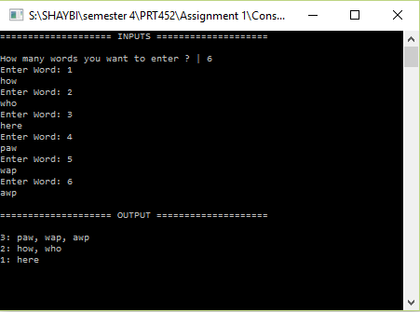

* Seconde image shows the program with 7 different inputs:

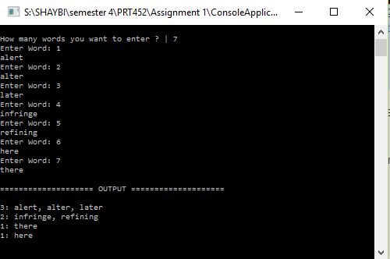

* Third image shows the programme with 10 different inputs:

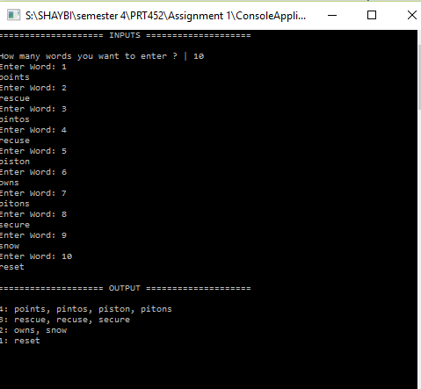

1. **Consider different test cases for normal and abnormal operation and inputs;**

These are my total test cases list :

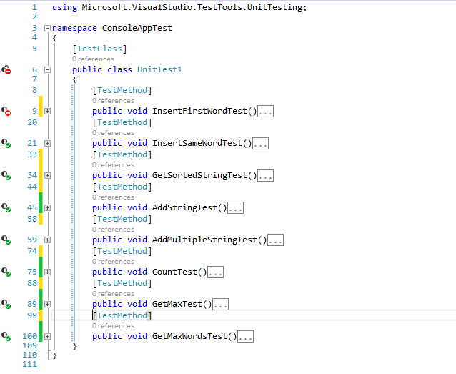

**Test case 1: Abnormal input test:**

In this test case I have checked if the user gives the abnormal input like this when checks if the user pass the empty string.

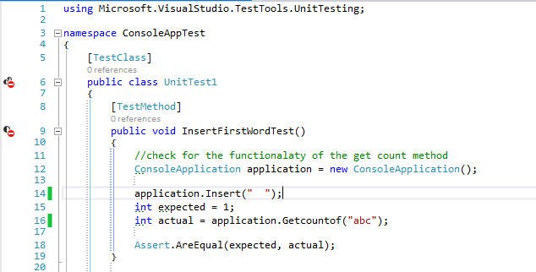

**Test result:**

Test has been failed because function received 0 as actual value instead of 1 in case of correct input.

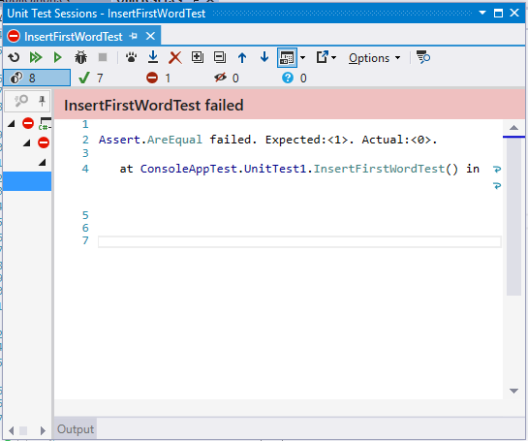

**Test case 2:**

It checks if the inserted word gets first arranged into the alphabetic order .so that we can compare it with the next words and grouped the same letters words later.

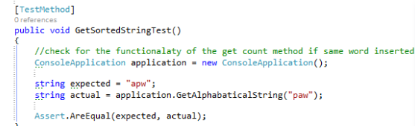

Result:

This function passed as the word ‘paw’ gets sorted into alphabetical order and actual value match with the expected which is ‘apw’ . 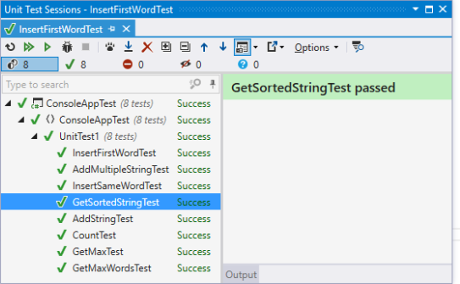

1. **Use test driven development method and present the TDD process in your code environment (not the general flow) in this assignment;**

**TDD case 1:**

I have used test driven development. All the functionality of methods were tested first. So different test cases was written to test the method. Here I am including two examples. Rest of the test cases can be find out in code uploaded in the github repository.

Tdd example tets case 1: in this test I have written the code to print the max number of words having same letters .orignal data string was this



The test case fail and instead of showing maximum number of words which is “paw ,wap,awp” (as can be seen in original data array above ) it was shoing just “here”

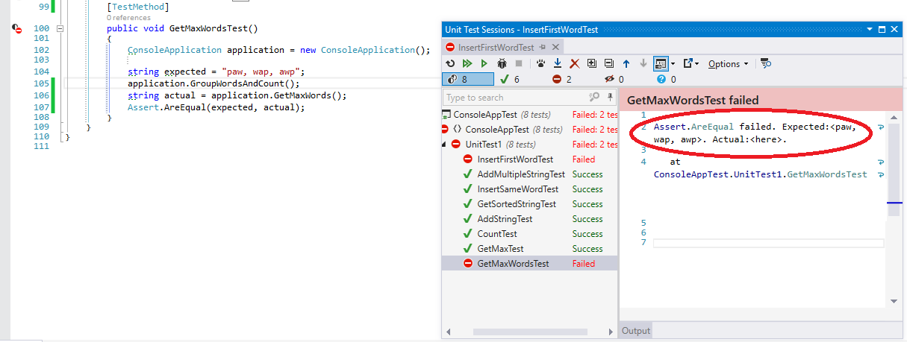

I have checked the code again and the error find out to be less then sign was written in the code instead of greater the sign . I fixed this error

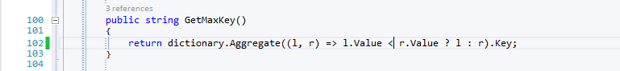

And the result was correct next time as shown in the pic:

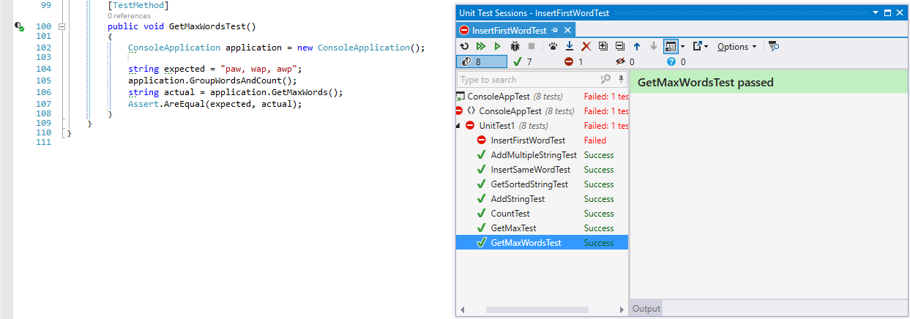

**TDD CASE 2:**

This test case was written to check if the multiple string of same letters was added and showed.so this function passing two words with same alphabets to the program and expecting the output with both of string with same letters separated by commas.

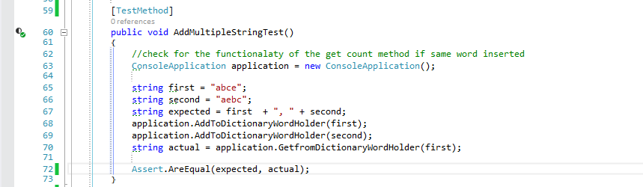

Test was failed and it troughed exceptions :

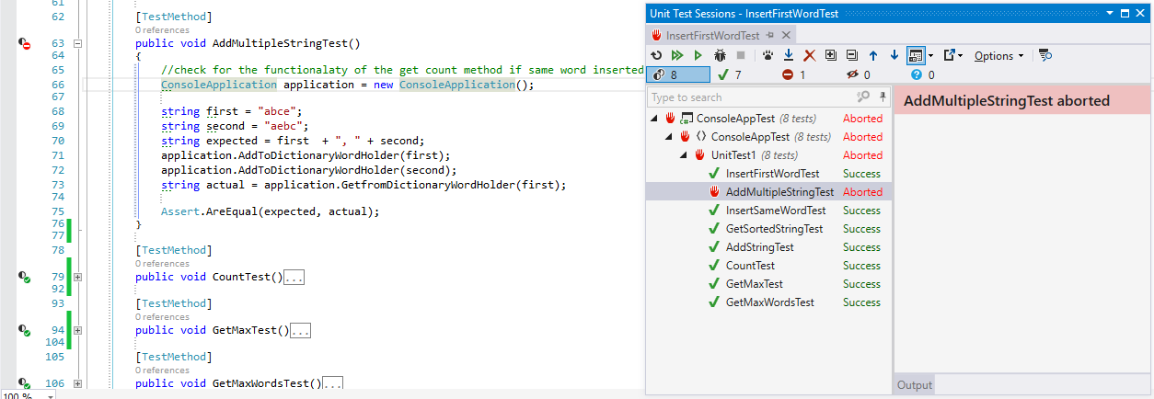

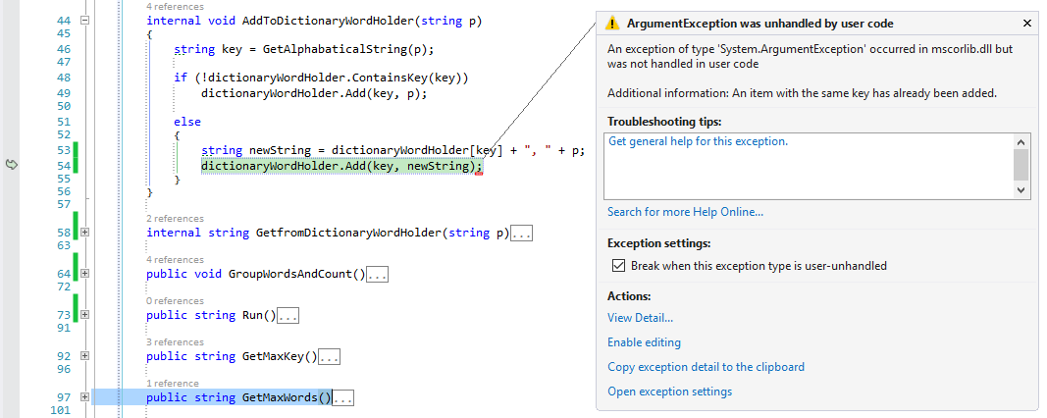

I have written test case for multiple string test either it gives me result of two words having same letters separate by comma. But the result shows exception. “An item has already been added.”

It happens because first time we enter the word into dictionary it save its key with ordered letter .it checks the dictionary if it have same key exists. It goes to the else case and generate the new string with ‘, ‘separated words and add this new string in to the dictionary with the same key .and if not its add the word into dictionary with alphabetical ordered key This the point where we get the error because dictionary has the same key already.

**Solution.** I remove the existing key and add the key again with the new string which have now two words with the same letters. This will work.

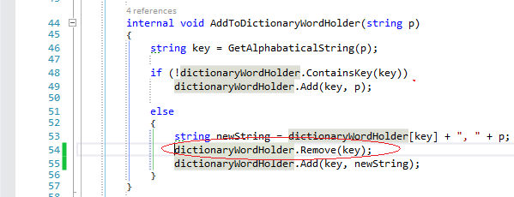

And run the test again it passed this time.

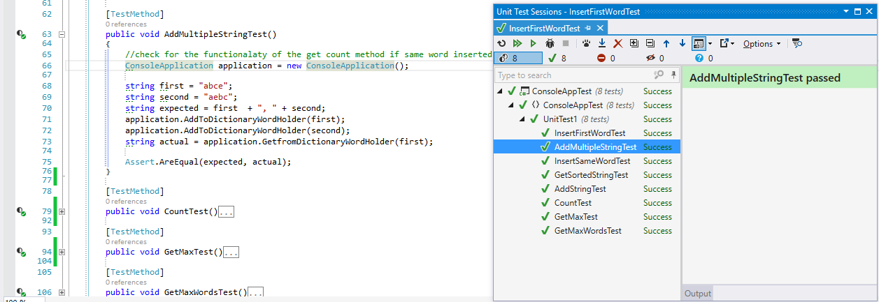

## Q3. What are the benefits of using change request form as the central document in the change management process?

During the lifetime of system, many changes take place because of organisational requirements changes with time and we cannot make 100% accurate system in first attempt, so changes always arise in a system and change management process ensures that changes are applied in a controlled way. According to Proscis’s research change management process can be divided into three phases. They are preparing for change, managing change and reinforcing change. (Prosci, 1996-2014)

Change management process is intended to ensure that changes are applied in managed process and priorities are given to urgent and cost effective changes. Change management process concerned with approval of changes that are worthwhile, track which component of the system have been changed, analysing the cost and benefit of change. Change management process initiated right after customer completes and submit a change request, this could be a bug report describing bug/error in a system, or a request for additional functionality. Changes may be submitted by change request form. (Sommerville, 2011).

Change request form (CRF) act as central document in change management process because change request is usually submitted using change request form. It records all the information that is shared between all the stakeholder and groups involved in change management. There are many benefits of using change request form.

* Record all the changes requested
* Cost benefit analysis of the requested change.
* It helps monitor the effect of change that was implemented.
* Record all the dates, when it was requested, approved implemented and validated.
* Track the progress of change requested, as it records all the decision made at each stage of the process.
* It identify the business need for each change request.
* Priorities the urgent change request.
* Impact of change in a system if approved.
* All the stakeholder are on same page with formal approval of change.
* Records decision made at each stage of change request process.
* Records estimated cost of the change and recommendations regarding the change

That is why it really important to formally record the change request and all its information using change request form .Without proper change management process , developing teams may encounter delays in the project ,cost overruns , difficulties implementing many changes without proper record.

**Reference**